Name: _______________________
Class: ________________________

“So if you come across a problem that grabs you, let it keep you up at night,
Engineering Fair
From Paper Napkin to Prototype*

Add your SCHOOL NAME
allow yourself to be fascinated, because there are so many lives to save.”
Nikolai Begg, MIT student (https://www.youtube.com/watch?v=TRajLqEaWhQ)

Foundation

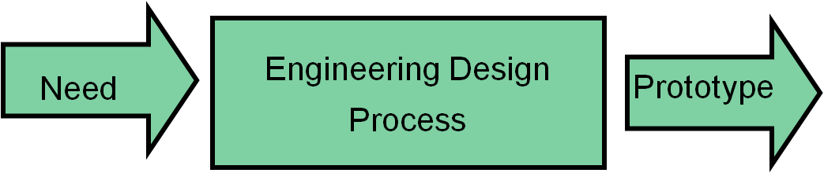

* Adapted from "Engineering Fair/Invention Convention From
Paper Napkin to Prototype" by Tracy Davis
Contents Page
Sample Letter to Send to Parents..………………………………… 3
Weekly Assignments and Homework…………………………….. 4
Engineering Design Process ……………………………………… 5
In-class Napkin Activity…………………………………………... 6
What Makes a Great Science Notebook? ………………..………... 6
Has Anyone Invented this Already? ................................................. 7
Topic Selection Worksheet ……………………………………….. 10
Literature Review Worksheet………………………………………. 13
Writing the First Draft of your Review …………………………….. 14
Engineering Fair Proposal ………………………………………….. 16
Putting together your display board ………………………………… 17

Sample Letter to send to parents:
Dear Parent/Guardian,
The students will be participating in an engineering fair that will focus on medical problems. It can be overwhelming for some students who may not have participated in this kind of event before. The most important advice I can give students is to complete each homework assignment as it is listed in the packet, and to always strive to ‘go above and beyond what is expected’.
This year, students who receive a superior ranking at the school fair in January will be invited to participate in the BEST (Bridging Engineering, Science and Technology) Medicine Engineering Fair. The BEST Medicine Engineering Fair will be held on Saturday, March 12, 2016. You can learn more about this fair by looking at the BEST Medicine Engineering Fair website: www.uakron.edu/bestmedicine/.
While this is a student project, the students will need your help and support. There are a number of suggestions and project ideas that can be found at www.uakron.edu/bestmedicine/resources.dot. They will need your help when it comes to gathering supplies and finding information for their Literature Review. I am sure they will value your input when it comes to constructing their display.
I look forward to working with your children to reach a common goal – scientific and engineering success. Talent is to be found in every corner of the world but opportunity is not. Giving students an opportunity to realize their creativity and innovation is the goal of our Engineering Fair.
Please sign below to indicate that you are aware of the project.

Sincerely,
**Add your name**

Student name: __________________________ Science teacher: ______________
Parent signature: ________________________ Date: _______________________

Due Date | Points | Project Component and Homework  Work will be completed in language arts and science
Week 1 | 5+5 | Homework: Visit the BEST Medicine website (www.uakron.edu/bestmedicine). Look at the list of topics, choose one that interests you, and write in lab notebook. (Due Wednesday)
Week 2: | 20 +20 | Complete napkin activity.  Homework: 1) Complete your patent search at home. 2) Make notes about what you find with regard to similar devices. 3) Complete Patent search worksheet (Due Wednesday)  Complete a preliminary Topic Selection worksheet.  We will work on the worksheet in class, but you must come to class with your topic. This is not the proposal; it is the first step toward preparing your proposal.  Homework: Have your topic selection worksheet signed by a parent.
Week 3: | 20 | Homework: 1) Bring at least three articles, books, or magazines to class to begin your Literature Review. 2) Start gathering building materials.  Literature Review: You will start writing your review in class.  Homework: The first draft of the literature review is due on Friday (Be sure to save your document if you type it because it is the first part of your research report.)
Week 4/5 | 20 | Engineering Fair Proposal Due.  In-class writing. Once this has been completed and signed you can begin building your prototype.  Homework: 1) Build your prototype. 2) Purchase display board
Week 6 |  | Build your prototype
Week 7 | 25 | Share your prototype with the class. Make changes based on suggestions.
Week 8: | 25 | Have 5 people provide feedback – a minimum of 5 surveys  Begin putting together your display board and practicing your presentation and prepare your elevator speech.
Week: 9 | 50 | Complete poster board and refine speech  Final poster board check  Present at Engineering Fair

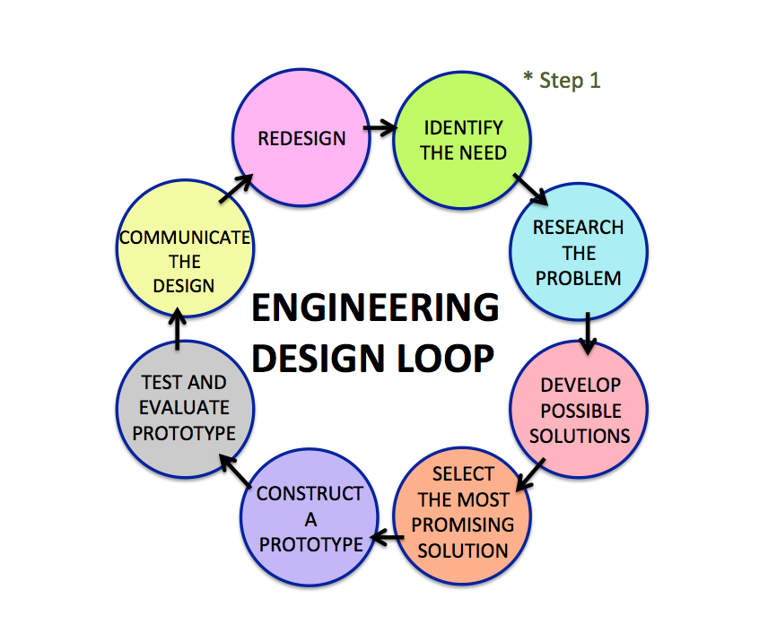

ENGINEERING DESIGN PROCESS
- Define the problem with criteria and constraints: By using real medical problems that the students select for their projects, students take ownership and are engaged in the process.
- Research the problem and generate ideas for a solution: Literature searches to understand the problem will develop literacy skills. Students assimilate this new information to develop possible approaches for problem-solving.
- Brainstorm possible solutions
- Select the most promising solution
- Build a model or prototype
- Test and evaluate the prototype
- Communicate the results: At the BEST Medicine Engineering Fair, students must communicate both in writing and orally by completing a poster display and written report and by providing a short, oral presentation to at least three judges. In order to provide the greatest opportunity for students to improve their oral communication skills, each judge approaches a student individually. Students must be familiar with the necessary vocabulary and understand their topic sufficiently to answer questions.
- Refine the design, which is often necessary. Continue to redesign, test, and evaluate until satisfied with the solution! Innovation rarely happens from the first attempt to solve a problem. Therefore, persistence is a necessary trait for the engineer.

In-class Napkin Activity:
You will be given a paper napkin. Draw, write, and sketch (in pen or pencil) the idea that you have for your invention. It should be a picture of your prototype. Your name and the date must be clearly displayed. Be ready to share your idea with the class (the napkin will be returned to you to place in your notebook for the engineering fair). Some of you may keep your original idea, while others may later develop a different idea for the engineering fair.

What Makes a Great Science Lab Notebook?
Your lab notebook is a detailed account of every phase of your project, from the initial brainstorming to the final research report. The judges will look at your lab notebook. Here are a few, easy pointers taken from Science Buddies: Rebbeck, Ph.D., Joanne. (2005, February 24). What Makes a Great Science Project Logbook?:

- Find a durable hardbound notebook or black and white composition book. Typically a lined journal works well.
- Label your lab notebook with your name, phone number, email address, and teacher's name in a prominent location. Make lab notebook entries in pen not in pencil. This is a permanent record of all of activities associated with your project.
- Number the pages in your lab notebook before using it, unless it is already numbered for you.
- Always date every entry, just like a journal. Entries should be brief and concise. Full sentences are not required.
- Don't worry about neatness. It is a personal record of your work. Do not re-do your lab notebook because it looks sloppy.
- You should work on your lab notebook consistently—it should be used during all phases of your project. For instance, in your journal you can write down ideas or thoughts for a project, phone numbers, contacts, sources and prices of supplies, book references, diagrams, graphs, figures, charts, sketches, or calculations.
- Use the notebook regularly and write down everything (even if it seems insignificant)!
- Glue, staple, or tape any loose important papers or items into your lab notebook. Loose papers or other unsecured items are prohibited, as they tend to fall out and can end up missing.

You must have a minimum of 12 lab notebook entries for this project.
Has Anyone Invented this Already?

Patent Search worksheet

Name: __________________

Before you get too far along with your idea, you should be sure that no one has thought of something like it before. You can search for similar ideas either at the U.S. Patent Office’s website or through Google. But first you need to come up with words that describe your idea.

Words to Use on your Search
What is your invention about? What words would you use to describe your idea? Using the answers to these two questions, generate 5 keywords that relate to your inventive idea.

________________________________________________________________
________________________________________________________________
________________________________________________________________
________________________________________________________________
________________________________________________________________
________________________________________________________________

1.) U.S. Patent Office Search
To do your research, you can start by visiting the U.S. Patent Office online and searching their patent database. The URL is: http://www.uspto.gov/patft/. Once you have found the site, go to “Quick Search.” When you arrive at the search page on the left you will see that you can enter two different search words. On the right, there are pull-down menus that show what part of the patent text you would like to search. Unless you are searching for a very specific term, select “Title” from both pull-down menus. Type in your search words, and then click “Search.” Try different combinations of keywords, two at a time. What patents do you find? Do any of them resemble your idea? List the names of similar inventions you have found below:

________________________________________________________________
________________________________________________________________
________________________________________________________________
________________________________________________________________
________________________________________________________________
________________________________________________________________

2.) Google Search Tool
An even easier search tool is Google. Go to http://www.google.com/patents and type in your keywords into the search field. Try different combinations of keywords, two at a time. What patents do you find? Do any of them resemble your idea? List the names of similar inventions you have found below:

________________________________________________________________
________________________________________________________________
________________________________________________________________
________________________________________________________________
________________________________________________________________
________________________________________________________________

SAMPLE Search: Finding and using keywords

Let’s suppose you are concerned about the plastic that is wasted when people purchase disposable water bottles. You think it would be better for the environment if people just reused a bottle and filled it with tap water. You have thought of a device that is similar to a filter. This device would snap into a water bottle and let you filter water before you drink it. So you would type, “water filter” in the USPTO site, and in Field 2 you might type “single bottle”. On the Google site, you would just type all of the words into the main search field. Try typing this in the search field: “water filter in water bottles”. This will pop up:
https://www.google.com/search?tbm=pts&hl=en&q=water+filter+in+water+bottle&gws_rd=ssl
You will see pictures and sketches of things that were invented before. This will help you determine if you have a new idea.
If you find that someone already invented your idea, don’t feel discouraged! You can change, modify, and build on the idea until it is new enough to be patented. Other people’s ideas and inventions will give you inspiration!
Modified from: http://www.bkfk.com/

Now tell me what you found? Was there anything similar to your design?

________________________________________________________________
________________________________________________________________
________________________________________________________________
________________________________________________________________
________________________________________________________________
________________________________________________________________
________________________________________________________________

Describe two or three devices that have some similarities or differences.
________________________________________________________________
________________________________________________________________
________________________________________________________________
________________________________________________________________
________________________________________________________________
________________________________________________________________
________________________________________________________________
________________________________________________________________

Topic Selection Worksheet

Name: __________________

Checklist: Circle your response.

- The solution I am proposing is unique. I have checked one of the patent websites, and I am confident that my device is unique.
Yes/No

- Does your project fall into a behavioral science category?
Yes/No

- Do you have human or animal subjects?
Yes/No

- Can you find at least 3 sources on your topic?
Yes/No

- Is the project challenging enough to work on for 6 weeks?
Yes/No

- Can you revise and make changes to your prototype?
Yes/No

- Is your project safe to perform? Explain.
Yes/No

- Will you be able to obtain all the supplies and materials you need in time to start building by the middle of end of December?
Yes/No

- Can you realistically complete your project in time?
Yes/No

- Will you complete the project with enough time to analyze and present the data for the judges?
Yes/No
- Will you be able to demonstrate that your design has a reasonable chance of solving the problem?
Yes/No

I have discussed my project idea and the checklist with my parent(s)/guardian. I am ready to commit and follow through with my engineering project. I have drawn a labeled picture of my prototype.

Student signature: ___________________ Date: _________________

Parent signature: ____________________ Date: _________________

Draw a detailed, labeled sketch of your prototype. Use a ruler for labels, draw in pencil, and title it. Try to follow the style of the drawing below adding labels instead of numbers.

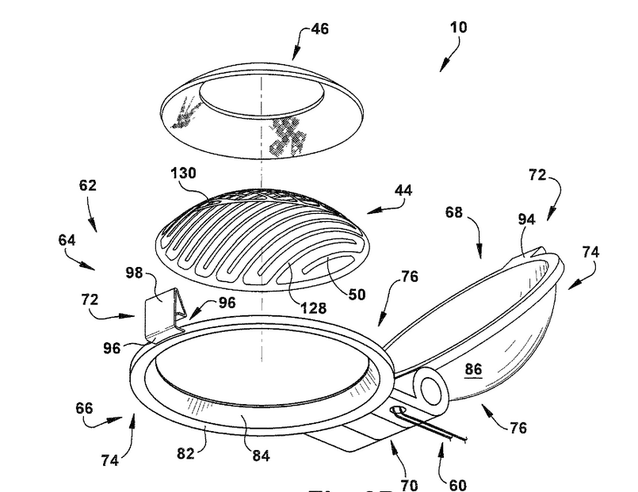

Singh, Rishi P., Lvovich, Vadim F., and Davis, Brian L. Apparatus and Method for Delivering a Therapeutic Agent to Ocular Tissue. The Cleveland Clinic Foundation, assignee. Patent US 8311624 B2. 13 Nov. 2012. Print.

Literature Review Worksheet

Name: __________________

Before you begin solving your problem and building your prototype, it is important to research your topic to find background information. You need to become a mini expert on your topic. When you are asked questions by the judges at the engineering fair, it is important that you are prepared to talk about more than just what is covered in your specific project. This can be difficult. You are in sixth grade not graduate school – yet! ☺ To make it easier, we will break the research down into sections.

Finding the information
You are required to have a minimum of 3 sources. These may be websites, books or articles from science magazines, or science journals.

The best place to begin your search is the library. The library will have magazines, newspapers, books, scientific references, and electronic resources on your subject. You are more likely to find what you need in large public libraries. Scientific journals can be found at these libraries. You can find texts on particular science topics in the 500s and 600s of the library stacks. The Internet is also a valuable tool. But, when conducting research on the Internet, make sure to use reliable sources. All information will need to be cited. When you are citing your information include the following: author, title, publisher, and copyright (year the source was published). Download copies of everything you use, including the website address.

List the title of your sources here.

- _________________________________________________________

- _________________________________________________________

- _________________________________________________________

- _________________________________________________________

First Draft of the Literature Review
Your review should be about 200-300 words and will be the introduction of your report. In the review you should:
- Introduce your topic (remember that the reader may know very little about your topic.) You will need to explain the problem and what groups of people are affected by this problem. It might be useful to have some idea of how many people are affected.
- Define important terms and scientific and medical language that is in your project.
- Tell the reader about any work, research, or similar innovative ideas that have already been completed related to your topic.
Writing the first draft of your Literature review
Introduce your topic (remember that the reader may know very little about the problem you are trying to solve). Also, try to include a statistic in this section.

Define important terms.

Tell the reader about any work or research that has already been completed that relates to your topic.

The Literature Review MUST be completed
before you start your experiment!

The other parts of the report can only be written after you have completed your experiment or built your prototype (engineering project).

No experiments should be conducted until you have had your Engineering Fair Proposal signed.

Engineering Fair Proposal

Name: __________________

The purpose of the proposal is to describe what you intend to do. Write in the future tense because you will be completing the work sometime in the next few weeks.
Title:
This could change as you progress through the project.
Objectives:
State the problem you are trying to solve and the idea that can solve this problem.

Goals:
State
1) your engineering goals and
2) constraints – be specific.

Materials:
Make a simple list of equipment or chemicals needed for your prototype.

Methods:
Describe the steps you will take to complete the construction of your prototype. Explain how you will test to see if your prototype will solve the problem.

Teacher Comments:
- Proposal

- Diagram

Teacher’s Signature:

Date:

Draw a detailed diagram of your prototype below.

Congratulations! You have successfully completed all the steps required to begin to build your prototype. REMEMBER: I cannot stress enough the importance of saving EVERYTHING!!!! Don’t make extra work for yourself!
The Poster Template.ppt is a PowerPoint template that can be can be used for creating the poster display board.
You should also have your lab notebook, your device or prototype (if you have made one), your report, and your folder with any other materials that you need to refer to when you are speaking to the judges. A typical engineering fair poster display is shown:
