Global Annotation

This portfolio contains three papers required both time and energy writing. A timed writing piece is also included. I have never seen myself as a strong writer and I do not particularly enjoy writing. I found it difficult to find papers I had written that pertained to the prompts presented by the writing portfolio. However, I do appreciate the process of producing this portfolio and I am happy with the end result. All of these essays relate to who I am as a student. I was able to incorporate a paper from my environmental studies major, one from my minor – political science and a description of an adventure I had over the summer in South Africa. For me this is my portfolios greatest strength, because I was able to use papers from passions of mine, and was not forced to include papers that were irrelevant to whom I was as a person. However, while my papers may have come from different backgrounds, there are many similarities and common themes throughout my paper. Sustainability has managed to make its way into all four of my papers, which while I believe to be something that needs to be taken seriously, I understand that their may not be much of a variety in my writings. While at Eckerd College, I have had to write many papers, and while each paper caused me stress and remorse, I now recognize that my writing ability has far surpassed any expectations I had as a freshman in college. While looking through all of my papers that I had written at Eckerd College, I was overwhelmed by all of the writing I had done. Writing these papers has helped me more than I cared to realize until now.

Annotation for John Muir Ideology

This paper called for me to emulate someone who held strong beliefs about their field (the environment) and who was also considered a leader in their field. I wanted to write about someone that I had learned about in many of my classes and whose philosophies I respected. I had to emulate that person and talk about injustices that are occurring in our world today. The person I chose was John Muir, not just because he was an environmentalist like me, but also because he was alive a long time ago, and it would be interesting for me to talk about issues that were relevant during the time that he was alive and are just as relevant today. In the paper, issues like rainforest degradation in the Amazon and water pollution in Cleveland are discussed. These are two issues that interested me greatly. I know John Muir would take a similar stance as me on those two environmental problems. I spent about eight hours on this paper including the time spent collaborating with classmates deciding whom I should emulate and what I should talk about. There was one draft before the final copy. I wrote this paper in the first semester of my junior year. I used APA format to reference this paper.

Environmentalism Ideology *– Being John Muir*

When I think of some of the happiest moments of my life, I think of the time I have spent in the wilderness. I have had many adventures, once I even rode an avalanche down a mountain in Yosemite, the experience felt like it lasted 5 minutes, but realistically must have only been about 10 seconds (Muir, 1994). It was one of the most exhilarating moments of my life. I feel the most free when I am experiencing nature first hand. Unfortunately, we - the human animal are slowly destroying natural areas that many see as priceless. I am not here today to talk about my personal freedoms that are being encroached upon, but the rather the freedom of the environment. To me, every species of plant and animal has a right to live on this earth, and that no one species should be able to play “God” and decide what lives and what dies. Humans still continue with little thought to destroy and mutilate the environment, with no respect for it.

I am here today to advocate for the environment and plead that we not wait until it is too late to do anything about the damage we cause on a daily basis. I am an environmentalist, and I believe that humans need to not only be concerned for the environment, but also try and help preserve and protect it. Environmentalism advocates the preservation, restoration and improvement of the natural environment. It strives to control pollution, while protecting our planets biodiversity. It seems to me, that we are putting growth before the health of our planet. By growth, I refer to the manner in which humans believe in taking resources from our environment, putting them into our economy, and then depositing our waste back into the environment. Our population is continuing to grow, which means more and more resources are being taken from the environment and transformed into waste. People seem to believe that we can grow infinitely, but there are not infinite resources for us to use. Do you remember in 1969, when the Cuyahoga River caught fire in Cleveland Ohio? We ignored all the signs of a bad ecosystem. The fact that there were no fish alive in the river spanning from Akron to Cleveland, a 40 miles of river that was completely devoid of fish (Rotman). It took a fire for us turn towards the river and try to bring it back to life.

We put growth before the well being of the environment, and as a result the river caught fire and caused one of the most influential environmental disasters in our in the world. Because of the fire, the Clean Water Act could be passed with no opposition, and the Cuyahoga River is now one of the most renowned fly-fishing locations in the United States. However, the earth cannot recover as fast as a river, and when enough damage has been done, there will be no turning back.

Now some may think that freedom for the environment does mean less freedom in other areas, particularly in business, and in growth. If we were to enforce a more environmental agenda, it is clear that industries may not be able to grow as fast as they would like. Businesses and those in developing nations would not support this agenda. However, it is indisputable that without a viable healthy environment, we as a species will no longer be free to live as we do now.

Forests across the world are in serious danger of being over logged, and the effects can be seen on a global scale. An estimated 80% of the world’s forests have been destroyed or are critically damaged. The Amazon is the biggest rainforest in the world, and is one of the most diverse. New species are being discovered every day (Rainforest Statistics Facts). Since 2009, 440 species have been discovered in the Amazon (Foley, 2013). This is one of the most environmentally rich areas on this planet, and it is also one of the most exploited. Over one acre a second is being deforested in the Amazon River basin. Given that an estimated 25% of our prescription drugs come from the Amazon, a greater emphasis needs to be placed on the importance of this magnificent forest, and resource. Around 17% of the forest has been lost in the last 50 years, mostly due to forest conversion for cattle ranching. Deforestation in this region is particularly rampant near more populated areas, roads and rivers, but even remote areas have been encroached upon when valuable mahogany, gold and oil are discovered (Rainforest Statistics Facts).

Another example of tragedy of deforestation is Papua New Guinea. Over half of their forests will be destroyed by 2021. This country is home to many forest dwellers that live a simple life, and are able to live in a sustainable way in these forests. More and more of these people are being forced out of their homes because their government is not willing to stop exploiting the forests due to the fact that the trees can be sold to developing nations in order to generate short term profits (Reed, 1997).

In order for our economy and our natural world to coexist, our industry must downsize. For example our agriculture industry produces too much food. We produce enough food to feed 10 billion people a year. As a result, nutrients are being taken out of soil, and wasted for profit (Gimenez, 2012). Forests are also destroyed in order to create farmland that did not need to be developed. Here, capitalism caused farmers to produce too much, at the expense of the environment.

We are forsaking our environment for progress and development. Some have the belief that technology will eventually save the environment due to inventions becoming more efficient, however the fact remains that there are just too many people on this planet, consuming too much. If we wait until the future, it will be too late, and we will have lost much of our biodiversity. We are currently going through the biggest mass extinction since the dinosaurs died 65 million years ago (Britt, 2006). If trends continue, over half of the species living on earth will be extinct in 100 years. The time for change is now, and it is time we start putting the earth before ourselves. In order to improve the freedom of the environment, we need to take away some of the freedoms and liberties that we have given to ourselves and return some of these to the earth.

Works Cited

Britt, Robert Roy. "Humans Fuel Worst Extinction Since End of Dinosaurs." *LiveScience*. TechMedia Network, 20 Mar. 2006. Web. 07 Dec. 2013.

Britt, Robert Roy. "Humans Fuel Worst Extinction Since End of Dinosaurs." *LiveScience*. TechMedia Network, 20 Mar. 2006. Web. 07 Dec. 2013.

Butler, Rhett A. "Amazon Destruction." *Mongabay.com*. Mangabay, 2010. Web. 07 Dec. 2013.

Foley, James A. "Monkey That Purrs like a Kitten Among 440 New Species Found in Amazon Rainforest." *Nature World News RSS*. Nature World News, 26 Oct. 2013. Web. 07 Dec. 2013.

Gimenez, Eric Holt. "We Already Grow Enough Food For 10 Billion People." *The Huffington Post*. TheHuffingtonPost.com, 02 May 2012. Web. 07 Dec. 2013.

Muir, John, and Lee Stetson. *The Wild Muir: Twenty-two of John Muir's Greatest Adventures*. Yosemite National Park, CA: Yosemite Association, 1994. Print.

"Rainforest Statistics Facts." *Rainforest Statistics Facts*. N.p., n.d. Web. 07 Dec. 2013.

Reed, Richard K. *Forest Dwellers, Forest Protectors: Indigenous Models for International Development*. Boston: Allyn and Bacon, 1997. Print.

Rotman, Michael. "Cleveland Historical." *Cleveland Historical*. Cleveland Historical, n.d. Web. 07 Dec. 2013.

Annotation for The Effect of Bird Decoys on Bird Diversity and Populations in Eckerd College

This paper was written for my environmental biology class. My classmates and I documented the different bird species abundance on campus at specific locations. Data collections were completed at various predetermined times during the day. I used Excel to create the graphs and tables, and PowerPoint to create the map of Eckerd College. I spent 15 hours on this paper including the time I spent walking around campus and gathering data. I received guidance from my professor for the entire paper. There were about three drafts before the final copy. I am including this paper because it is my favorite research paper that I wrote and I found it pretty interesting to do a paper related to fieldwork. I used APA to reference this paper.

**The Effect of Bird Decoys on Bird Diversity and Populations in Eckerd College**

**Stuart Davis**

**Environmental Biology**

**12/04/12**

**Abstract**

In this study, the effect decoys had on wading birds was studied in ponds located on the Eckerd College campus. Groups of students collected data for four days by counting the number of birds out at four ponds on the Eckerd campus. These data were obtained before and after decoys were positioned at one of the sites (Chapel pond). The birds were classified into four categories; Waders, Water birds, Perching birds and Birds of Prey. From the results, it was possible to determine if decoys had any effect on bird populations. At one of the locations (the one located farthest from where the site where decoys were placed and also measured the lowest salinity levels), there was a significant reduction in the number of birds after decoys were placed at the Chapel pond (p < 0.05).

**Introduction**

There have been numerous attempts to influence bird behavior, especially by managers of fish hatcheries who want to minimize losses due to predator birds eating their fish (Parkhurst, Brooks and Arnold, 1987). There have been reports (Round, Gale and Brockelman, 2006) describing the use of live bird decoys for the purpose of attracting and trapping wild birds in Thailand. Another reason people may want to attract birds to a pond in order to conduct research (Crozier and Gawlik, 2003). Furthermore, someone may want to use decoys could be to deter other birds from coming near the pond, or communities may want to reintroduce birds to an area following nearby construction. Aside from protecting fish or trapping birds, naturalists may want to attract birds to ponds in order to increase the diversity to the pond. In this experiment conducted at Eckerd College, we also used white flamingo decoys to see their effect on wading birds. The purpose of this experiment was to see if decoys could be used at Eckerd College to attract more bird diversity.

**Methods**

For this experiment, we collected data from four ponds on Eckerd’s College campus. In St. Petersburg, it is very warm year round, and when collecting the data, the temperature stayed around mid 700F. The first pond, Fox, is located right next to Chapel pond, and it has the same sidewalk running next to it. It has about 40% of its edge covered by trees, 10% by shrubs, and 50% covered by grass. There are also a few buildings next to Fox pond. The second pond, Chapel Pond, has about 70% of its edge covered by trees, 10% covered by shrubs and 20% covered by grass. There are a couple of buildings next to it, and also a sidewalk running past one side of the pond. Another pond we collected data on was Zeta pond, which is near students housing. It is close to the Gulf of Mexico, but has very little trees on the edges compared to the other ponds. About 40% of its edge is covered by trees, 10% covered by shrubs and 50% covered by grass. There is also a sidewalk running next to this pond. The last pond we collected data on was Forever Wild pond, which is on the far east side of campus near a highway. Here it is more secluded then at the other ponds, with more trees and vegetation. Here about 80% of its edge were covered by trees, 5% covered by shrubs, and 15% covered by grass.

For each pond, the number of birds and species at each of the ponds was recorded from 12:00 pm to 4:00 pm 11/14 to 11/20/2012. Multiple groups would go out at different times and count the different birds at each pond. This included birds that were close to the ponds, or in the ponds. Each group would spend close to 15 minutes at each pond. The ponds were surveyed fifteen times before the four decoys were put in Chapel pond and fifteen times afterwards. If a bird could not be identified then it was omitted from the surveys.

Once the data was collected, it was compiled into a single spreadsheet. In order to determine the species diversity we used the equation of P=1/ sum \!\,(pi)2.

|  |
| --- |
|  |

**Results**

A summary of the bird data is shown in Table 1, and key characteristics of each location are shown in Table 2. Prior to decoys being introduced at Chapel, the two sites with the greatest species richness were Forever Wild and Fox (22 and 20 respectively), with the other two sites having a richness of 11 (Table 1). The total number of birds at Fox pond went down from 350 birds with 21 species, to 273 birds with only 17 species. Chapel also decreased in the number of birds. It decreased from 74 birds to 63. Zeta’s abundance went from 74 to 76 and the species richness went up from 11 to 17. Forever Wild’s total abundance went from 360 birds to 171, and the species richness went from 22 to 20 species. Zeta pond had the highest species diversity, and Fox had the lowest diversity. The White Ibis was the most common bird.

The p values for each of the ponds (Table 3) showed no significant differences due to the decoy except for Forever Wild. This site had a p-value of 0.0353, indicating that there was a reduction in species numbers when decoys were used at Chapel pond. This finding is supported by the pre/post data comparisons shown in Figure 4.

In our study, an increase of Great Egrets, Snows Egrets, and also Tricolored herons was found. The total abundance at Chapel pond prior to decoys being added was 350, and post decoy the abundance dropped to 273. There was a substantial drop in White Ibis’s in Chapel, but these data did not result in an overall significant effect at this location though.

**Discussion**

Possibly the most relevant study conducted using decoys took place in the Everglades. The study found that birds were heavily attracted to white flamingo decoys, and the birds were typically more attracted to the southern ponds (Corzier and Gawlik 2003). From the data collected at Eckerd, we can conclude that the decoys had little to no effect on the species diversity except for the Forever Wild location. This could be due to the distance between Forever Wild and Chapel pond, or other issues such as water salinity or vegetation differences at each of the ponds. Fox and Chapel had the highest salinity, and Forever Wild and Zeta had the lowest (Table 2). However, Zeta had the highest species diversity, and Forever Wild had the highest species richness. Zeta had the highest diversity, and Forever Wild had the highest species richness. One reason for this could be that there were fewer birds at Chapel is because it is in the middle of campus, and has many buildings nearby. Forever Wild is secluded, and also much bigger so it probably also has more food for the birds to forage, with less of a disturbance from people. Also, the birds flying by Eckerd College could have seen Forever Wild first, as it is closer to the mainland, and passing by birds could more easily see it than the other ponds.

At the Chapel pond location, there seemed to be a large change in the number of White Ibis birds after decoys were used. In fact, the number dropped from 37 down to zero. In contrast, the numbers of some species (e.g., Great Egret) increased slightly. This finding is in line with findings that White Ibis behavior in the Florida Everglades (including reproduction) is more sensitive to changes in hydrological conditions and prey availability than is seen with Great Egrets (Herring, Gawlik, Cook and Beerens, 2006). Furthermore, the White Ibis is a “searcher” species in population decline that specializes on highly concentrated prey, whereas the Great Egret, is a visual “exploiter” species that requires lower prey concentrations (Beerens, Gawlik, Herring and Cook, 2011).

For future research, data collected at night would be useful to see if there could be any difference with bird diversity. Data could also be collected on different decoys amounts at each pond to see if the number of decoys affects the population of birds being attracted to each pond. Decoys could also be placed at each of the ponds at different times to see if some ponds attracted more birds than the others did. Another variable I would try to quantify would be the fish population, to see if some ponds have more food than others. The last thing I might change would be to do an extensive water quality test to see if that had anything like salinity has something to do with the bird populations.

There were a couple biases in the data. Data was only collected during the day time, so we did not get a good record of nocturnal birds at the ponds. Another bias was that data was collected in only one month of the year. If we could do the study during different seasons, maybe we could understand how birds interact with decoys better. One last bias in our research is that we did not look at the different vegetation around the ponds, and that could influence the attraction of certain species to different ponds.

**Works Cited**

BEERENS, J.M., D. E. GAWLIK, G. HERRING, AND M. I. COOK. 2011. Dynamic Habitat Selection By Two Wading Bird Species With Divergent Foraging Strategies in a Seasonally Fluctuating Wetland. The Auk 128:651−662

CARRICK, R. 2012. The Food and Feeding Habits of the Straw-necked Ibis, Threskiornis Spinicollis (Jameson), and the White Ibis, T. Molucca (Cuvier) in Australia. CSIRO Wildlife Research 4:69 - 92

CROZIER, G. E. AND D. E. GAWLIK . 2003. The use of decoys as a research tool for attractive wading birds. Journal of Field Ornithology 74: 53-58.

HERRING G, D.E. GAWLIK, M. I. COOK, AND J. M. BEERENS. 2010. Sensitivity of nesting great egrets (Ardea Alba) and White Ibises (Eudocimus Albus) to reduced prey availability. The Auk. 127:660-670.

PARKHURST, J.A, R.P. BROOKS, AND D.E. ARNOLD. 1987. A Survey of Wildlife Depredation and Control Techniques at Fish-Rearing Facilities. Wildlife Society Bulletin 15:386-394.

ROUND, P.D., G. A. GALE AND W. Y. BROCKELMAN. 2006. A comparison of bird communities in mixed fruit orchards and natural forest at Khao Luang, southern Thailand. Biodiversity and Conservation. 15:2873–2891

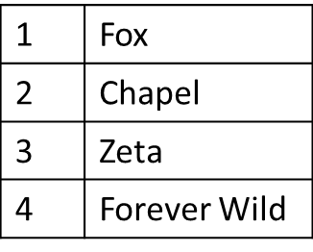

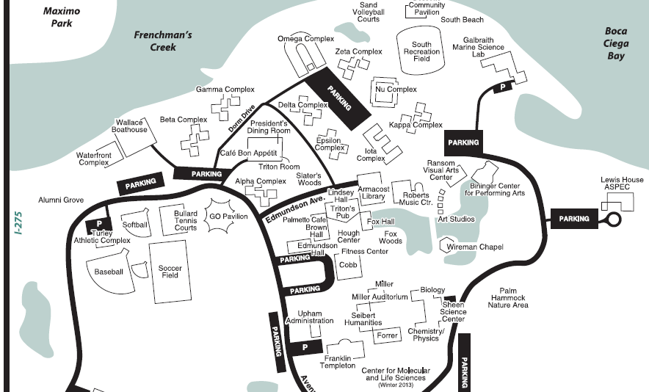

Figure 1. Bird populations were studied at four locations on Eckerd’s campus. Location 4 (on eastern edge of campus showed a reduction in bird numbers when decoys were placed at Chapel pond.

Figure 2. Bird populations at Chapel pond before and after decoys were placed.

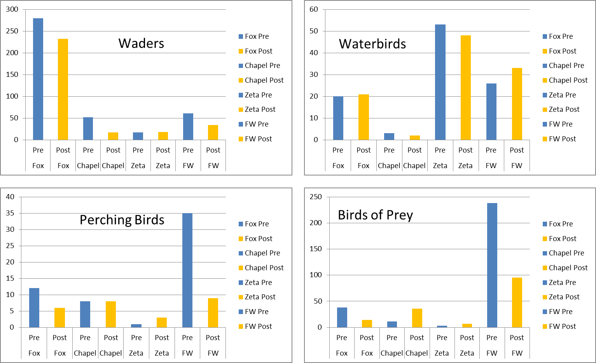

Figure 3. Total numbers of four categories of birds at four locations before (pre) and after (post) the use of decoys at Chapel pond. Note that the numbers of Waders decreased at three of the four ponds after decoys were used, and that there were dramatic reductions in the numbers of Perching Birds and Birds of Prey at the Forever Wild location after decoys were used at the Chapel pond.

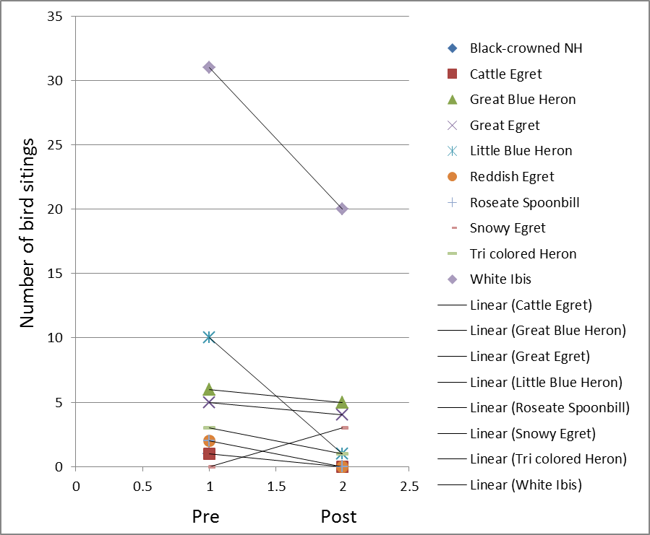

Figure 4. At Forever Wild, most species numbers dropped post decoy use at Chapel pond.

Table 1. Summary of bird data

|  |  |  |  |  |
| --- | --- | --- | --- | --- |
| **Pond** | **Species Richness** | **Species Diversity** | **Total Abundance** | **Most Abundant bird species** |
| **Fox** | 20 | 1.99 | 350 | White Ibis |
| **Chapel** | 11 | 3.58 | 74 | White Ibis |
| **Zeta** | 11 | 4.48 | 74 | Moorhen |
| **Forever Wild** | 22 | 2.71 | 360 | Laughing Gull |

Table 2. Summary of pond features

|  |  |  |  |  |
| --- | --- | --- | --- | --- |
| **Pond** | **Salinity (ppt)** | **% of pond edge covered by trees** | **% of pond edge covered by shrubs** | **% of pond edge covered by grass** |
| **Fox** | 20 | 40% | 10% | 50% |
| **Chapel** | 25 | 70% | 10% | 20% |
| **Zeta** | 8 | 40% | 10% | 50% |
| **Forever Wild** | 5 | 80% | 5% | 15% |

Table 3. Statistical test (comparing ponds before and after a decoy was placed at Chapel pond). Numbers in the table refer to p-values.

|  |  |  |  |  |
| --- | --- | --- | --- | --- |
| **Pond** | **Fox** | **Chapel** | **Zeta** | **FW** |
| One-sided matched T test | 0.14505 | 0.1895 | 0.4549 | 0.0353 |

Annotation for ThinkImpact Paper

This paper is about my experiences that I had while interning for ThinkImpact in Hlalakahle South Africa. I received credit for this internship, and it lasted for about two months. I felt the need to incorporate this paper into my writing portfolio because I am really proud of what I was able to accomplish while in South Africa. I have been fortunate to travel extensively, but I have never been anywhere out of the country by myself. This trip was an adventure for me and I was really proud of the experience that I obtained from this trip. I spent about 12 hours writing this paper after I got back from my internship. There were four drafts of this paper, for one of them I received feedback from my professor prior to handing it in. I used APA to reference this paper.

South Africa has been in the news lately due to the Olympic Games, success on the golf course and because of the international focus on Nelson Mandela’s 94th birthday celebrations. In two years the country will celebrate its twentieth year since the end of apartheid. However for the Shangaan people, in the village of Hlalakahle, little has changed. Poverty, made worse by drought and lack of basic services provide an environment that deprives people of a chance at achieving their full potential in the new South Africa.

According to Sen, “Development consists of the removal of various types of unfreedoms that leave people with little choice and little opportunity of exercising their reasoned agency. The removal of substantial unfreedoms it is argued here is constitutive of development” (1999, *xii*). Sen believes there is strong evidence that economic freedom and political freedom support each other. “Education and healthcare help people to overcome deprivation but it is the identification of freedom that is vital in development.” (1999, *xii*)

According to Griffiths, “Developing world” is a catch-all phrase that lacks precision and explanatory power”. (1998, 1) People differ in their views of what development is. Some believe it is economic growth or progress toward democracy but others believe it is great empowerment and dignity (Griffiths, 1.) It is the second description which best fits the goal and approach of ThinkImpact, an organization that described itself as “People Powered Global Development”. This student group tries to affect change in four countries in Africa: South Africa, Rwanda, Kenya and Ghana. While it might not meet the standard of development as seen by Amartya Sen, ThinkImpact’s view of development, allowing scholars and local villagers to work together to develop a business is an approach that has merit and the program hopes to effect true change and sustainability.

To understand the challenges facing scholars in the ThinkImpact program, a description of the village is required. Hlalakahle is part of the greater township of Manyeleti and the municipality of Bushbuckridge, and is an area with an unemployment rate of 69%. (South African Census, 2002) The population of the village is about 2,000 and women primarily are head of the household. Most of the men are migrant workers who leave their families to go to urban areas. Pensioners over the age of 65, and those with dependents receive a monthly government check for R 1000. This is equivalent to $125 (personal communication with villagers.) The government heavily subsidizes housing. According to the villagers, a plot of land costs about R100 and the labor to build a house is about R2000. The materials have to be supplied by the owner. This means that a simple house consisting of a living room, kitchen, and three bedrooms with electricity can cost less than a thousand dollars, but that is large sum for most people in rural South Africa. This region is part of the former homelands that are a throwback to the apartheid government, in which people were forced to move to insure what the apartheid government claimed, was “separate but equal”. There is electricity but it is not reliable in Hlalakahle. Approximately 80% of the households use pit latrines. “Using pit latrines pose a potential pollution threat to the surface and ground water resource of the area.” (<http://www.nra.co.za/live/content.php?Item_ID=52>). Due to the severe water shortage, all the villagers rely on water pumps, water trucks or dam water. During the duration of my stay as a participant at the institute, an eight week period; no rain fell, making it the fifth straight month without rain. Drought has persisted for fifteen straight years. There are few government services. However, there are small health clinics like the one in Gottenburg (a neighboring village) that my group of scholars visited. The primary aim is to try to deal with the high incidence of HIV/AIDS. Traditional healers who claim to cure are used by many in the community. (Personal interview with healer) In a rural area like Hlalakahle, the three industries, mining, tourism and agriculture are not options for the people. The lack of rain and ready access to water thwarts their attempts to produce successful crops. There is also a large erosion problem. (See Photo1) Some academics like G Pascal Zachary believe that Africa’s transformation will be due to agriculture and that farmers will put food on the African table (Zachary in Griffiths, 64). This is not possible in Hlalakahle. Brown refers to hydrological poverty, “living without enough water to produce food or in some cases, even basic hygiene” (Brown in Griffiths, 170). While Hlalakahle has enough water for basic hygiene, they cannot produce their own food. Any thoughts of scholars encouraging new agricultural endeavors had to be abandoned.

Tourism is successful in the region especially as there are a number of national and private game parks but these highly sought after jobs are often not available to the people due to lack of education and transport to and from these jobs. There is some public transport in the form of a bus route, while a few residents do have cars. There are two schools in the village, an elementary and secondary school and a number of religious organizations, including the Zionist Christian Church, the Roman Catholic Church and the Zion Christian Fellowship that play an important role in the lives of the people. It is a village that seems to have insurmountable problems and has been identified by the South African government as “having one of the largest concentrations of poverty in the country.” (<http://thinkimpact.org/innovation-institute/where-we-work/south-africa/>) This is the environment that the institute ThinkImpact chose for scholars, (Undergraduate American students) and challenged them to find ways to work with local people (villagers) to create a small business.

The first step in preparing us for the South African experience, involved and online course through Brazen U (see www. Brazen.com). The organization trained us to first assess the assets and resources of our home community. This was an easy task, but my town, Moreland Hills Ohio, is very different to Hlalakahle, Mpumalanga. It is upper middle class suburb of Northeast Ohio. My initial impression on my arrival in Hlalakahle was that there were no assets in the village. It was however clear from my first dealings with the community that while they may not have your typical tangible first world possessions or beliefs, there were aspects of the village that were vital to community success. There was no crime, people did not steal from one another, and community and family were of paramount importance. The description of life in Manyeleti provided as background for scholars who would be going to South Africa seemed almost too good to be true “Family is at the center of life.  The loyalty, respect and tradition of families in Manyeleti is striking.  Young people are deeply committed to their families and their connection to their family is one of their number one priorities.  Watching fourteen-year-old boys walking their little sisters to school or little girls with their baby sisters swaddled around their back, it is clear that families are an important part of the culture in this community.  Many times young people wake up hours before school to help their mother and grandmother to collect water, or travel to the market to get food.  When school is finished they come home to help their younger siblings or to continue with chores around the house. This is all done out of respect and loyalty for their family. Young people are expected to take on ‘adult responsibilities’ and grow into adulthood at a very young age.  Families in Manyeleti feel that caring and nurturing for their children is very important.  In addition, elders in the community instill a sense of community and trust throughout the entire village.” (http://thinkimpact.org/innovation-institute/where-we-work/south-africa/­) However, this was an accurate account of the community. Scholars witnessed a community that valued each member and as a result our village was highly functioning. Each scholar became part of the home family and the community and found that we now had mothers, fathers and even aunts and grandparents.

According to Sen, “The ends and means of development call for placing the perspective of freedom at the center of the stage. People have to be seen in this perspective as being actively involved… not just passive recipients…” (1999, 53) Throughout the time in the institute it was clear that ThinkImpact believed that the people in Hlalakahle would be part of any solution that could be found.

The philosophy of ThinkImpact has six core principals; true integrity is self-responsibility, empathy comes from listening, ideas matter but die without follow through, consistency and communication build high impact teams, decision making should be based on data and facts, and you must find your voice. These principals played a key role in my South African experience.

Saul Garlick, CEO of ThinkImpact is a social entrepreneur. “He is best known for his leadership on poverty alleviation in Kenya and South Africa where he has played a direct role in the implementation of over 50 development projects including schools, sports fields, sanitation projects and community halls. Saul has led over 150 people to live and work in rural Africa in the past 4 years and President Nelson Mandela has endorsed his work.” (<http://thinkimpact.org/innovation-institute/where-we-work/south-africa/>)

Before we could go to the village of Hlalakahle, all of the scholars and advisors were dropped off in Gottenburg, a nearby village in the northern part of Mpumalanga for a traditional welcome ceremony. (See photo 2) We were asked to sit down in front of a crowd made up of the villagers of Gottenburg, Hlalakahle, and Hklavakisa. I would later learn that six of us would be going to Hlalakahle. There were a number of speakers, who talked about how happy they were to have us in their villages and they wished us the best of luck. The high school students from Daimani High School prepared a skit for us. At first I found the play flattering, but it soon became overwhelming as the theme was about how the villagers could not solve any of their own problems themselves and they needed foreigners to come in and solve their issues for them. This goes against everything that Sen wrote about in his book Development as Freedom, how could foreigners coming in to solve your problems, be the solution? After the ceremony, I met my host mother and we began walking to Hlalakahle. I had this overwhelming feeling that I would be imprisoned for two months, and that I did not belong in Hlalakahle and that I could not help the villagers. This was probably caused by the play the high school students performed for us which resulted in feelings of panic. The initial impression was that the villagers were relying on me to fix their biggest problems, this would be impossible! Things improved the next morning and continued to improve throughout the entire trip. The feelings of imprisonment and helplessness disappeared.

The institute was clearly capable of equipping us to meet the challenges. The first phase of the institute – the Immersion phase had three objectives, which were: to build relationships in the community, to learn the culture, and to uncover the community’s assets. In order to do this, we were given a number of activities we could do in the village either by ourselves or with a translator. The activity we spent the most doing was character profiling. We were given a template to follow in our guidebook. (Garlick, 51) This activity required each scholar to go around with a translator and introduce ourselves and interview villagers about their life, their village, and their beliefs. This activity was important because it provided information about the village’s problems, and sought their input with regard to solutions. However, this activity frustrated me the most, as the villagers were not used to thinking about what they could do to fix issues; they were accustomed to having people give them the answers. They expected us to give them money or water to solve their problems. We were there for the opposite reason, to empower the people to find the answers themselves (with some guidance from us). Another issue I had with this activity is that the people would not answer our questions to the best of their knowledge. When asked what they do for fun, they would reply “nothing”. When asked what good they saw in the village, many of them said there was nothing good in the village. Throughout the entire immersion phase, I got angrier and angrier at the villagers, and thought that the next two phases would be hard. I did not want any of the people I interviewed to be on my design team due to their lack of creativity and motivation. However, I do believe that through other scholars and the CDF (Community Development Foundation) we were able to uncover most of Hlalakahle’s assets. In the interview process I did not develop as many relationships as the other scholars did, but I excelled at making relationships through playing soccer with the villagers. Because I had a soccer ball, the villagers would ask me to play with them constantly. Unfortunately, due to the workload given to me by ThinkImpact, I could not play as much as I wanted to. The immersion phase allowed me to bond with my new home family and become fully immersed in village life.

The second step was the Inspiration phase. It included the following: Build a Design Team, Brainstorm, Ask *How might we question.* This phase also had three objectives: to build a design team, brainstorm, and ask “*how might we questions*. In the beginning of this phase, the scholars had to determine which villagers to invite to be on the design team, and which scholar partner we wanted. There was the option to work alone. I did not enjoy this stage in the program, (see published blog – <http://blog.thinkimpact.org/2012/07/31/davis/>) as it led to a lot of butting heads, due to many scholars wanting to be on the same team. I found it to be extremely awkward. In the end it all worked out, as everyone ended up with a partner that was a good fit. We then discussed which villagers we wanted as part of our design team. These were people we had met in the village during our Immersion Phase. To do this each team made a list of our top ten people that we wanted, and compared them with one another. We ended up asking five people, all of which said they would be a part of our team. Our final team consisted of; myself, Danielle (my scholar partner from Georgetown University), and the villagers - Shoneth, Steven, Daisy, and Judy.

We thought that selecting a team was difficult but the initial brainstorming session with our new partners was even more difficult, because our team members did not see certain things as assets. For example, we considered children to be an asset, but the villagers viewed them as just another mouth to feed. After a couple of meetings, we were able to show them how things that one would never see as an asset can be so, if viewed from a different perspective. While brainstorming all of the different problems in the community, people were quick to point out that the lack of water and lack of jobs as the biggest problems, but as we could not solve those two issues given the assets in the community, so we probed for more. It was very important for the design team members to know the difference between needs based solutions and asset based solution are. Needs based solutions require things from outside the community, while asset based solutions come from inside the community. This concept was even lost on the majority of design teams, who wanted to use resources from outside their villages in order to fix an issue. After the understood that they needed to use resources from inside the community, we began crafting different *how might we questions*. The issue we unanimously chose was education. Assets that could be used in order to help students in school were selected. Because many of our village team members were interested in helping to clean up the streets in the village, and because of Danielle’s and my interest in recycled materials, we opted for recycled materials as our asset. Our final *how might we question* ended up being: How might we encourage education by using recycled materials? I was very happy with this final decision as from day one I knew I wanted to address the garbage issue in Hlalakahle. From my personal observation it was clear that there were no services provided to help remove the trash. There was refuse everywhere and the minimal amount of fresh water was polluted.

The third step was the Innovation phase which called for us to establish a context, –develop a prototype and gather feedback. The start of the innovation phase was a very exciting time for me; as I had been looking forward to it the entire trip. I was excited to start seeing what our team could do. The three objectives for this part of the process were to establish context, prototype and gather feedback. Because we wanted to help students in and out of school, our team decided that some of us should go to school for a day and see first-hand what the challenges are that students face. I woke up at 5:20 AM, as I had to walk to school and I met up with Steven, last year’s class president. When we got there, I was able to sit in a science class. Immediately I could see that there were not enough desks for the students. They had to write on their lap with notebooks that had paper covers, which offered no support. Another problem was that some students did not have a bag to carry their books in, so books were damaged, and some students struggled to carry their books home. These two student concerns became our teams’ primary focus, and we began coming up with ways we could make bags and desks using recyclable materials. Danielle and I had every member come up with his or her own design for a bag then allowed our team to create the design for the bag themselves while we went to prepare for another meeting. Our team found out that a majority of villagers end up throwing out their mielie meal bags. Pap, the staple food of South Africa is made from corn maize and we decided to use the maize sacks to make book bags. (See photo 3 & 4) By cutting them up and sewing them, we fashioned them to look like over-the-shoulder book bags. We did not want a single member’s idea to not be seen, so we had them each come up with a design to present to the team. My idea was like a drawstring back pack because I thought it would be the simplest, cheapest idea, and I wanted to bring something different to the table, as other designs looked quite similar. For our second item, we quickly figured out that we could not make desks out of recycled material, although, we could make lap desks out of sticks, string, cardboard, and chip wrappers (for a nice finish to the top of the desk). All of these materials were readily available.

The final step involved the Innovation phase which included both a showcase and exhibition. After we had finished our two prototypes, we had our first opportunity to show our product to the public. The showcase was held in our village where people were invited to come and listen to a presentation about our products and offer us feedback. Danielle and I were not allowed to speak, only the other design team members/villagers could answer questions about the product and tell everyone why we made it, and what we hope it will do for the village. The communities loved our ideas, and once more are made; they will be available for purchase. The lap desk did better than I thought as even villagers wanted to buy them. The lap desk was priced at R10, or $1.20, easily affordable for the villagers. We thought that would only sell them to the schools. The high schools principal was very eager to purchase the desks. The only piece of feedback that resulted in a change to our prototype is that we needed to make the lap desk waterproof. To make it water proof, we covered it with plastic bags. The showcase went very well, and we felt very prepared for the exhibition to be held in Gottenburg where all of the teams would pitch their innovations to the communities.

We prepared a skit for the exhibition. Two of our members acted as struggling students. This was due to a lack of desks, and trouble bringing their books home because they had no book bag. The presentation went very well. I also enjoyed seeing everyone else’s innovations. My proudest moment of the entire exhibition was when Shoneth, my design partner said while referring to another group, “they cheated, their innovation is needs-based, not asset-based”. At that moment I felt that even if our innovation did not generate any revenue, that at least I was able to create a mind shift in my design team. The community was very positive about our innovations, and in particular really liked the bag. (See photo 3) Other scholars commented on how they loved our ideas and wanted to buy bags from us if they could, but we did not want to sell our prototypes in case our design team needed something to refer to later in the production phase. The exhibition went off without any problems and everyone in our team was excited to start the next phase – developing the start up the business that we had created.

On the surface the success of the team can be judged by the small business we developed together. The villagers we left behind had two products to manufacture, and we were confident that they had a market to support their business. However, the impact of which I am most proud is the mind-shift we affected in people. When I left the village, I saw a great difference in the way people viewed the things around them. When asked, they could not identify any assets in their village, but eight weeks later they were able to look at the world around them differently and identify a number of possible assets and had the tools to hopefully develop other products or innovations. For me, as a first world person, I developed personally. I now appreciate things like hot showers, the value of education, running water, public transport, and the freedom to choose a career path.

# Bibliography

Davis, S. (2011). *http://blog.thinkimpact.org/2012/07/31/davis/*. Retrieved August 2012, from

http://blog.thinkimpact.org/2012/07/31/davis/.

Department of Justice . (199s9). *Truth and Reconciliation Commission of South Africa Report.*

London: Bath Press.

Griffiths, R. J. (2011). *Developing World 10/11.* New York City: McGraw-Hill.

Roads Agency. (2012). *Toll Tariffs & Discounts*. Retrieved Augast 24, 2012, from

http://www.nra.co.za/live/content.php?Item_ID=202.

Sen, A. (1999). *Development as Freedom.* New York: Anchor Books.

ThinkImpact. (2012). *South Africa*. Retrieved from http://thinkimpact.org/innovation-

institute/where-we-work/south-africa/).

ThinkImpact. (2012). *The Innovator.* Washington D.C.: Saul Garlick.

Appendix 1

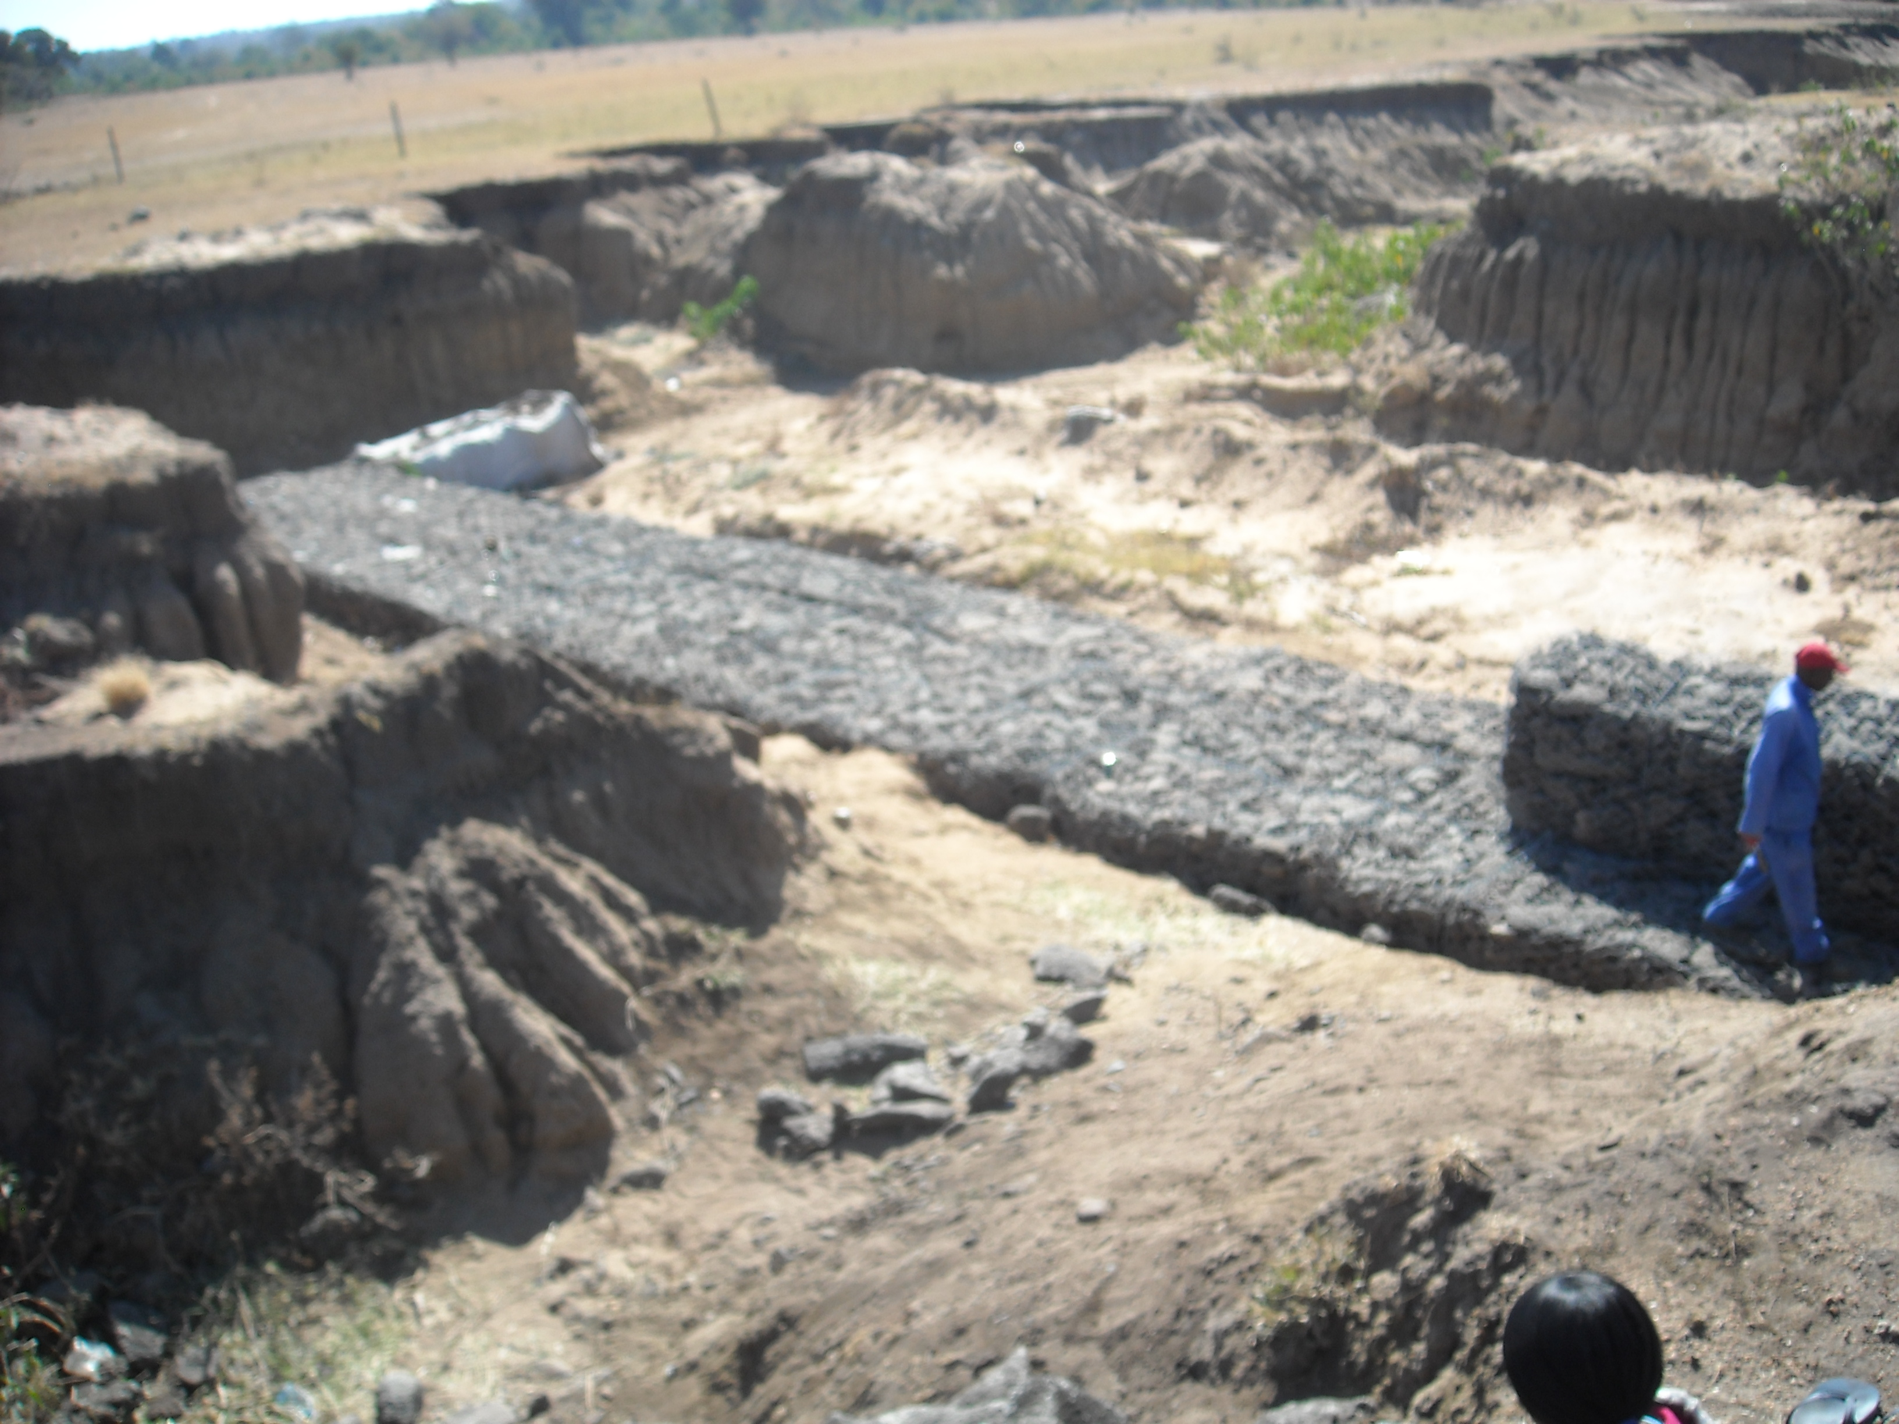

Photo 1: Erosion in Hlalakahle

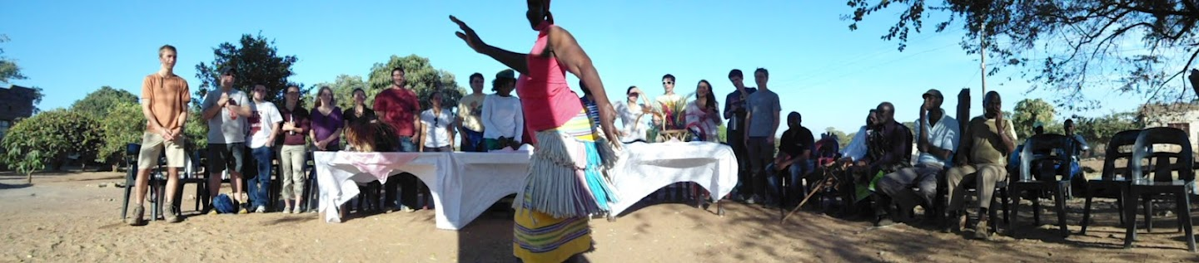

Photo 2: Traditional Welcome Ceremony



Photo 3: Maize Meal sack

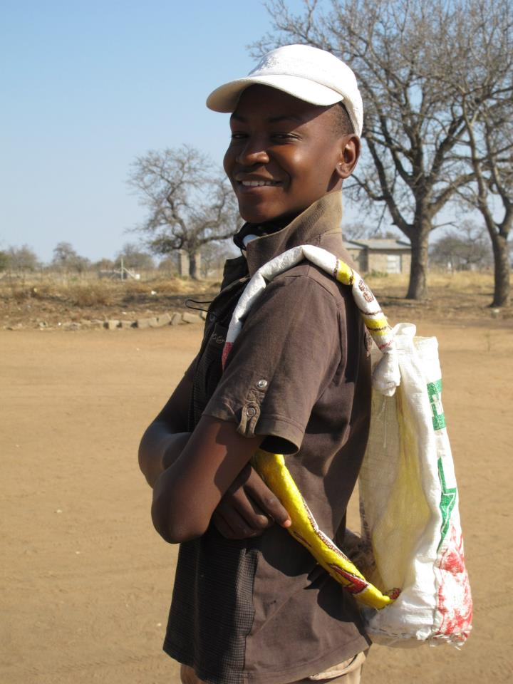

Photo 4: Prototype of backpack

Annotation for Timed Writing

For the timed writing I was to write about a cultural experience that I had while I was a student at Eckerd College. I chose to write about my experience in ThinkImpact because it was such a big change for me. I know I had written about it in a previous paper, however I felt that both papers had a place in this portfolio as the paper I wrote for college credit details my time spent oversees and my second paper more goes into how I felt about the people and my surroundings throughout the whole experience. My timed writing does not go in to as much depth, however that is because it covers a broad topic, and I did not have as much time to complete it as I would have liked.