ABSTRACT TEMPLATE FOR 2020 MIDWEST REGIONAL ASB MEETING
¹First Author (Presenter) and ²Additional Author(s)
¹Cleveland State University, Cleveland, OH, USA
²Additional Author University, City, State, USA
Email: firstauthorsemail@example.com

INTRODUCTION
This template details the formatting requirements that must be followed for abstract submissions. All abstracts for the 2020 Midwest Regional American Society of Biomechanics (ASB) meeting must be submitted through the following link:
https://csuengineering.formstack.com/forms/asb_2020_registration_form.
Abstracts can be submitted from January 1, 2020 to August 10, 2020 at 11:59pm (EST). All abstracts must be submitted as PDF files.
Abstracts will be read by reviewers at Cleveland State University. The reviewers will determine if abstracts should be accepted based on their relevance to ASB’s primary discipline categories: biological sciences, exercise and sports science, health sciences, ergonomics and human factors, and engineering and applied science. All biomechanics related research is encouraged for submission! Reviewers will also recommend if an abstract should be presented as a poster presentation or podium presentation. Emails concerning acceptance and presentation format will be sent in early March.
All undergraduate and graduate students are encouraged to submit abstracts. The goal of this ASB meeting is to encourage participation in a friendly, student-focused environment! The 2020 national ASB meeting will be held in Atlanta, GA from August 4th-August 7th, 2020.

METHODS
In the beginning of the abstract the two-column layout will begin after the title, author affiliations, and email address. If an additional author institution needs to be added, the two-column orientation can be edited to begin a line later.
The abstract must be no longer than two 8.5 inch x 11 inch pages. Left and right margins must be set to 0.5 inches, and top and bottom margins must be set to 1.0 inches. Font must be Times New Roman, 12- point. Columns are set to the “justify” setting. This template is designed to follow these specific formatting instructions. Do not change the template formatting when writing your abstract. Abstracts that do not follow the formatting instructions may be rejected without review.
The abstract title should be in bold, capitalized letters at the top of the page. Directly below the title should be the author’s names. Subscripts indicate the authors affiliated institution. Use different subscript numbers to represent different institutions (and likewise, use the same number to represent the same institution). Add more authors as needed. The email address given should be for the corresponding author. The following sections must be included in the body of the abstract in bold, capitalized letters:
INTRODUCTION, METHODS, RESULTS AND DISCUSSION, CONCLUSIONS, REFERENCES, ACKNOWLEDGEMENTS.
After exporting your abstract to a PDF (.pdf), check that the formatting and position of any figures and tables did not change.
RESULTS AND DISCUSSION
Use this section to share your results and your interpretations of them. Tables and figures should be labeled. Table titles go above the table, and figure titles go below. Times New Roman 10-point font can be used for table and figure titles. Indicate the corresponding figure and table when referencing them in text. (Example): Anterior-posterior (AP) and medial-lateral (ML) center-of-pressure (COP) excursions were 14±0.7 mm and 10.2±0.85 mm, respectively (Fig. 1).
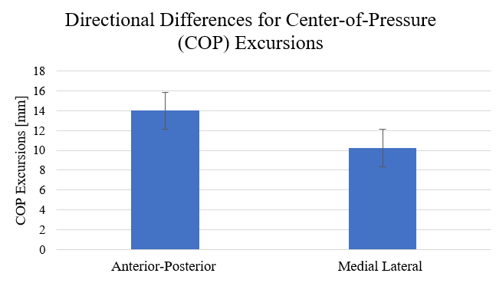
Figure 1: Choose a short and effective figure caption that does not simply repeat the title on your figure. Color can be used in figures.
Tables should be referenced in a similar manner (Table 1).
Table 1: Insert a table caption.
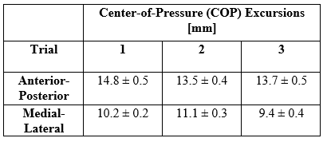
Be sure that all figures and tables are accompanied by text. In other words, do not include figures and tables without an explanation of their contents.
CONCLUSION
It is crucial that abstracts are submitted on time. Abstracts must be submitted on the 2020 Midwest ASB website. Abstracts that are submitted after the deadline will be rejected without review and not considered for a presentation. Presentation types will be either podium or poster, and you may indicate your preference when submitting your abstract. You will be notified in early March of your abstract acceptance and presentation format.
Questions concerning abstract submissions, or other aspects of the 2020 Midwest ASB Conference should be directed to the 2020 Conference Chair:
Brian Davis, PhD
b.l.davis@csuohio.edu

REFERENCES
Since the abstract is only two pages, references should be used only when necessary. Try and limit references to five or less. References should be cited in text with brackets [1]. Examples of references are journal articles [1], other presentations about this work [2], or books [3]. If there is more than one author, include “et al” for the remaining authors.
1. Last name, First initial, et al. Title of Journal. Pages, Year.
2. Last name, First initial, et al. Title of Presentation. City, State, Year.
3. Last name, First initial, et al. Title of Book. Publisher, Year.
ACKNOWLEDGEMENTS
Acknowledgements are optional but should be made to any funding source, or individuals who had a significant contribution to data collection, analysis, or interpretation. Cleveland State would like to thank Parker Hannifin for their generous donation towards this conference. We hope you have a fantastic time at the conference, learn something new, and enjoy your time in Cleveland!

